**PROJECT DEVELOPMENT PHASE DELIVERY OF SPRINT 3**

|  |  |
| --- | --- |
| Date | 12 November 2022 |
| Team ID | PNT2022TMID24184 |
| Project Name | Project – Personal Assistance for senior citizens who are self-reliant |
| Team members | B. Thejaswini  Y.Prathyusha  K.Mrudula  V.Susmitha |

**SPRINT III: Development of Python code (Software implementation) Outline of Sprint 3**

This sprint delivery document contains the following,

1)Python code to receive data from node red and send to IoT Watson platform 2)Updation of nodes in the node-red platform

3)The results of the web UI after deploying.

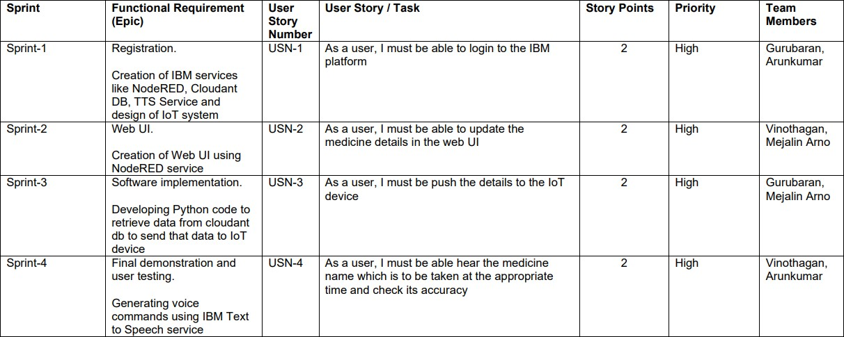

1. **Python code to receive data from node red and send to IoT Watson platform**

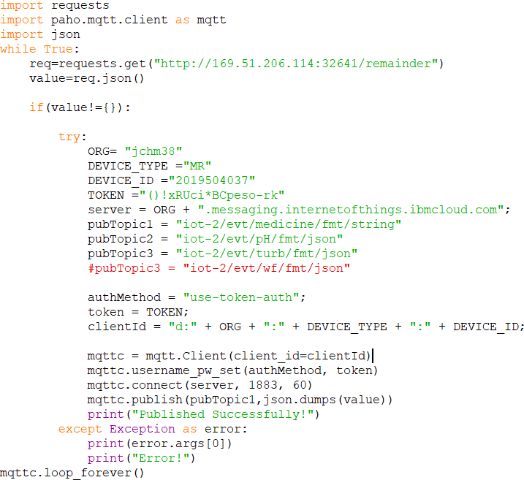

1. **Updation of nodes in the node-red platform**

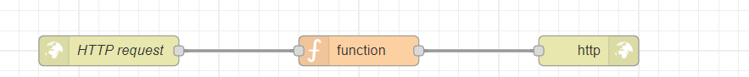

The following function is returned in order to store get the medicine name in http to facilitate request and response via python code

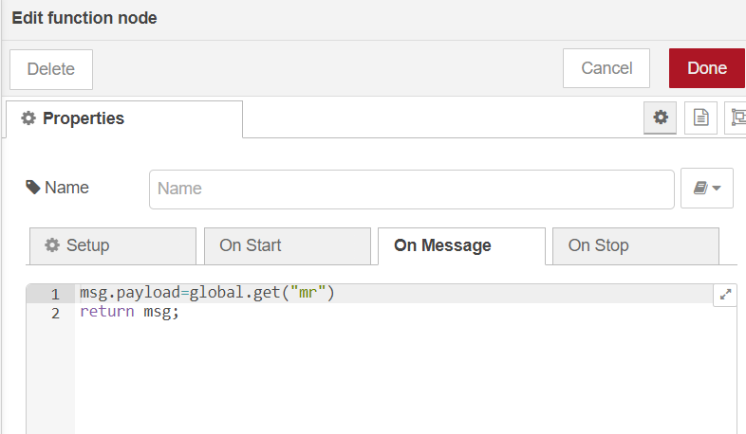

**The Updated node red flow diagram**

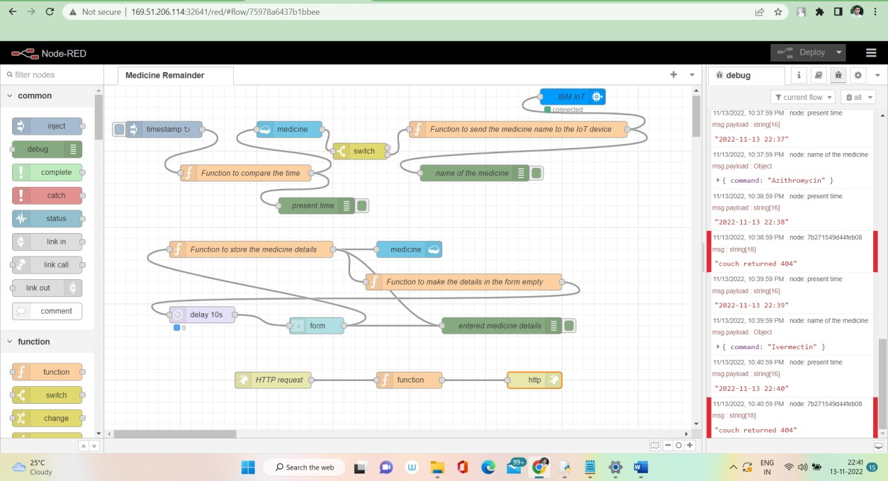

1. **The results of the web UI after deploying**.

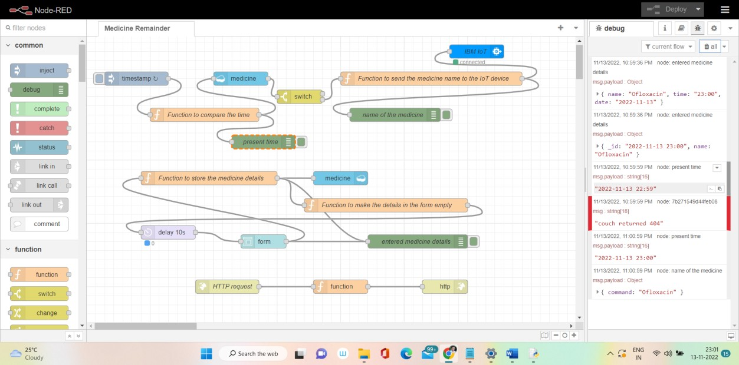

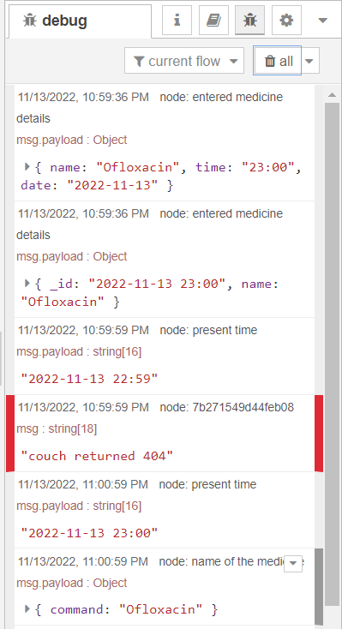

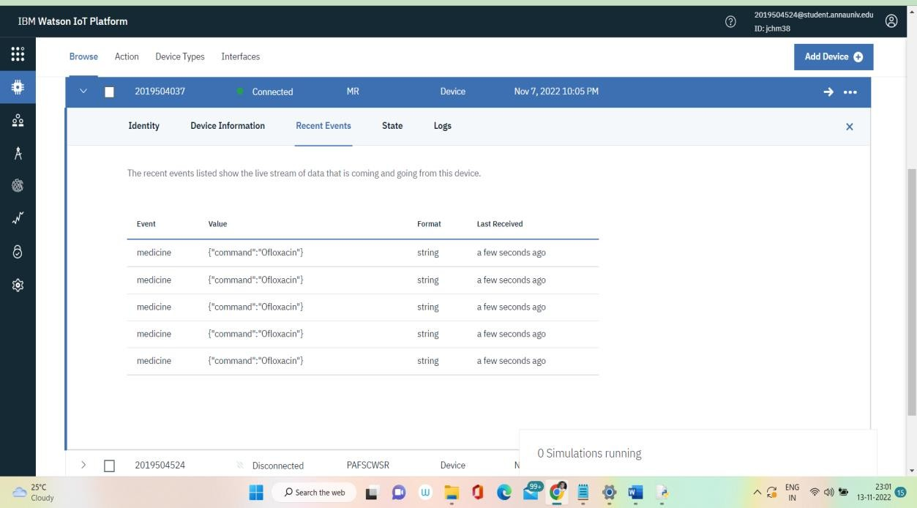

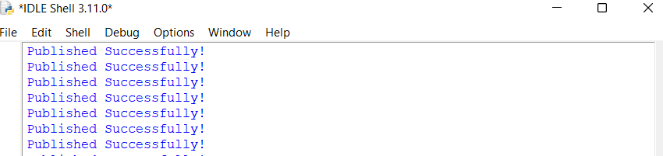

The above result reveals that the medicine name is sent to the IoT Watson platform using the above developed python code. The medicine name “Ofloxacin” is scheduled to be took at 23:00. The name of the medicine is displayed in the IoT platform at 23:00

The next step would be implementing TTS service to spell out the medicine name at the appropriate time.

**\*\*\*\*\*\*\*\*\*\*\*\*\*\*\*\*\*\*\*\*\*\*\*\*\*\*END OF REPORT\*\*\*\*\*\*\*\*\*\*\*\*\*\*\*\*\*\*\*\*\*\*\*\*\*\*\*\*\*\*\*\***